### User Adoption

### Delete A Record(Occasion)

|  |  |
| --- | --- |
| Team id | AD47707C5D4D5109D5E480002BDB30D5 |
| Project Tittle | Build an Event Management System using salesforce |

1. Click on App Launcher on left side of screen.
2. Search Event Management & click on it.
3. Click on Occasion Tab.

### Screenshot (7).png

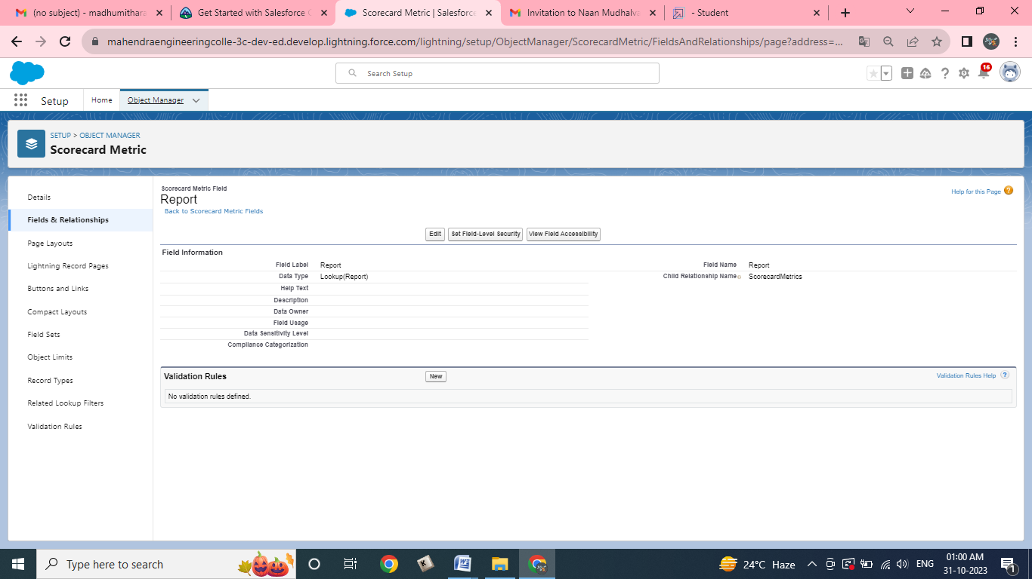

1. Click on Arrow at right hand side on that Particular record.
2. Click delete and delete again.

